A106 Care and Reproductive
Management of the Mare

Name _____________________________________ Date _______________

Label the parts of the equine female reproductive tract.

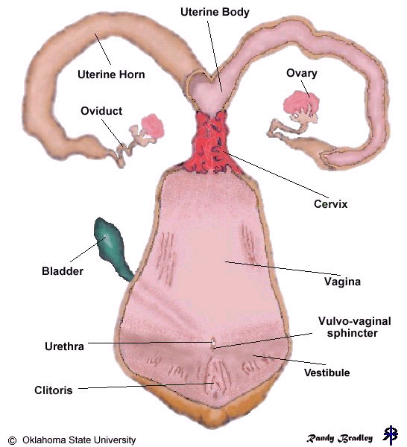

Mare Breeding Characteristics
Estrus begins in horses from __________________ months of age.

Fillies should be _____________ months old before breeding.

The Reproductive Cycle
Mares begin cycling in the ___________________________.

Estrus lasts ______________________ days in the early spring and will shorten to

_____________________ by May or June.

During estrus ___________________________ develop in the ovaries.

The follicles produce the hormone _______________________________.

Several follicles may develop simultaneously, but usually only one follicle will

_______________________.

When the egg is ready, the follicle will rupture releasing the _____________. This is

called ______________________________.

Ovulation occurs no more than ________________ days before the mare goes out of heat.

Occasionally, two follicles will ovulate which can produce _________________.

This is undesirable because twin fetuses have a high risk of ___________________ and cause complications during birth.

After ovulation, the crater left in the follicle will develop what is called a

__________________________.

The corpus luteum produces the hormone ________________________________.

Progesterone causes the mare to go into _______________________ (go out of heat).

If conception occurs, the corpus luteum will continue to produce _________________ and the mare will not come into estrus again until after parturition.

The hormone progesterone also helps prepare the ________________________ for the developing fetus.

If conception does not occur, _____________________________________ are released which causes the corpus luteum to fade and the mare will cycle again.

Fertilization
The __________________________ leaves the ovaries and enters the oviduct.

The ___________________________ is where fertilization takes place.

The ovum is viable for __________________ hours while sperm can live for

_____________________ hours.

It takes ________________ hours for the sperm to travel through the cervix and oviduct and reach the egg.

Due to these time constraints breeding, is recommended ___________________ days prior to ovulation.

Fertilization occurs when the male ______________________ (sperm) and the female gamete (egg) unite.

The DNA located in the head of the spermatogonia is then transferred and combined

with the DNA of the egg forming a ___________________________.

The zygote then travels down the oviduct and enters the uterus in about __________ days.

In horses, while in the uterus, the embryo is very __________________, bouncing

around between the uterine horns until day _____________________ where it settles in one part of the uterus and implants itself.

Gestation
From ovulation to parturition, the average length of gestation is ___________ days.

Polyestrus
Polyestrus means a mare is a ___________________________ breeder and will come into estrus several times per year, but does not cycle year around.

Mares will start cycling irregularly in ___________ and ____________ as the days start to get longer.

The peak of the estrus cycle occurs in _______________ when the days are the longest.

Wild horses breed during this time so that foals are born during the

_______________ of the year when feed is apt to be the best.

In ______________________, as the days shorten, the mare ceases to cycle regularly.

By late ___________, she stops cycling altogether and remains inactive through the winter months.

Today the tendency is to mate horses earlier and earlier because there is an economic advantage to having a larger more developed foal in the sale or show ring.

This, however, interferes with the mare’s _______________________________ and reproductive efficiency is sacrificed for economic gain.

If early breeding is going to occur, supplemental ________________________ is required.

A mare requires about __________ days of artificial lighting before ovulation occurs.

In order to induce ovulation in early Feb. to produce a Jan. 1 foal, artificial lighting

must be started in late _______________ early ______________.

__________________________ of daylight and supplemental light and _____ hours of darkness is required.

Light can be two 40-watt light bulbs.

______________________________ supplementation is often also used.

Rebreeding

At _________________________ days postpartum, most mares will come into heat.

This is called the ____________________________.

The conception rate for foal heat is only about _________________.

Mares bred on their foal heat run a greater chance of developing uterine

________________________.

The ______________________ heat after delivery is the best time to breed.

Equine Artificial Insemination
Involves the collection of ______________________ from a stallion and the deposition of the semen into the mare by artificial means.

AI Advantages

1.

2.

One ejaculation from a stallion produces nearly _________________ sperm cells.

3.

4. Stallion semen can be _______________________ which will allow the stallion to continue to produce offspring long after he is dead.

Frozen semen results in ___________________________ rates in horses compared to fresh semen.

Some breed registries such as the Jockey Club will not allow AI.

Other breed registries will allow AI but not with frozen semen. Such is the case with Quarter horse & Standardbred registries.

Once collected, fresh semen is measured, and a semen ____________________ is added.

It is then evaluated for ___________________, ___________________, and

________________________.

Next it is slowly chilled, and shipped.

Fresh semen should be inseminated in the mare in less than _________ hours from the time it was taken from the stallion.

Equine Embryo Transfer
What is an embryo transfer?

A new embryo can be ______________________________ removed from the uterus of a donor mare and implanted into a recipient mare.

What are the advantages and disadvantages of embryo transfer?
Advantages

1.

2.

Disadvantages

1.

2.

Embryo Transfer Procedure Phases:

1. Synchronization of the _____________________ and the __________________.

2.

3.

Synchronization
Synchronization requires the use of hormones __________________________ or

_________________________.

Usually ____________________________ are synchronized for the one donor mare.

The donor mare is carefully palpated, cultured, and bred.

The ovulation of both the donor and the recipients must be timed to within _______ hours.

Embryo Flushing
Embryo flushing is performed ______________ days after insemination.

A sterile solution is used to ______________ the microscopic embryo out of the uterus.

The embryo is then developmentally _______________ and __________________ on a scale of 1- 4, 1 being excellent.

The embryo is loaded into a uterine transfer __________________________ and

mixed with a special ________________________________ and is implanted into

the ________________________ of the most synchronized recipient.

The overall chances per cycle for a successful transfer with a young healthy donor are

about _______________________ % and ____________________ % for older mares.

The recipient mare in no way contributes to the _____________________________ of the foal.

Cloning
Cloning has occurred in nature for billions of years in _________________ and some lower animals. Cloning is asexually producing offspring that are genetically identical to a parent plant or animal.
For example, a plant grown from a leaf cutting is a clone of the original plant because they are genetically identical.

In the laboratory, scientists use somatic cell nuclear transfer techniques to produce animals with genetic material identical to just one parent.

At present, ______________________________ have been successfully cloned; among them

1. 4.

2. 5.

3.

Using microsurgery techniques, scientists remove the _______________________ from an egg cell, which contains the cell’s genetic material, creating an enucleated egg.

The genetic material from a somatic cell is removed from the cell and injected into the enucleated egg.

What is a somatic cell?

An electric pulse ______________ the egg cell and new genetic material.

The cell is then treated in media that allows it to develop into an _______________ that can be implanted in a surrogate mother’s womb and carried to term.

Equine Cloning
Cloning will not replace sexual reproduction in animals, but allows scientists to increase

the impact of important ______________________________ in populations of animals, and may be the only means of reproducing some animals.

For example, cells from _____________________________ animals may be used to increase populations of some species, but cloning them also requires

_________________________________ that are genetically similar to carry the embryos to term.

The birth of Idaho Gem, the first cloned _______________, presents other important opportunities.

Mules are crosses of horses and donkeys and, like most hybrids, are sterile.
The only way to produce genetic copies of an outstanding mule is through cloning.

Understanding the unique requirements for developing cloned equine embryos may also open the way to cloning horses with important genetic traits.

For example, Funny Cide, a winner of the Kentucky Derby and Preakness, is a gelding, a genetic dead end unless cloning could produce copies of him.
University of Idaho researchers began trying to clone a mule a year after Dolly the sheep

was cloned in _________________.

Out of ______________ attempts, there were ________ pregnancies and _________

carried to full term. A mule named Idaho Gem was born on ____________________ and was the first member of the horse family to be cloned. Two other clones were born in June & July.

The mule clone is the full sibling of a champion _________________________ owned by Idaho businessman, Don Jacklin, of Post Falls Idaho.

Donald W. Jacklin paid ____________________________ to finance the four-year mule cloning project.

There are differences already evident in the mules because the three foals that are

genetically identical triplets had different _______________________________.

Idaho Gem, the first, was the heaviest at birth, weighing ___________ pounds. Utah

Pioneer, the second, was the lightest, weighing _______ pounds. Idaho Star, the third

born, weighed _________ pounds.

Both the mothers’ role and each clones’ response to its environment as the mules grow

will provide insight into the debate about whether _____________________ rules an animal’s future.

“It really does zero in on what is ____________________________________ and what other factors come into play,” Vanderwall said.

The three clones, all cloned from the same fetal mule ________________ line, can only be compared to each other. They were not cloned from an adult so there is no mature animal with which to compare them.

The clones’ future probably will include ___________________________ as 2-year-olds. “They’re bred to be athletes, so one test of their fitness will be their athleticism,” Woods said.
A frequent question fielded by the scientists has been whether the clones’ personalities are different. Vanderwall said he believes Idaho Gem and the youngest clone are the most similar, adding, “They’re the most personable, and they like to approach people.”
From that aspect, there does not seem to be a direct link to the mares’ personalities.
Idaho Dawn, the surrogate mother of the youngest clone, is the most wary of the three horses.

“What can we learn? What can we study about the clones? What becomes evident over the life of the clones?” Vanderwall said those will be the basic questions guiding future research.

